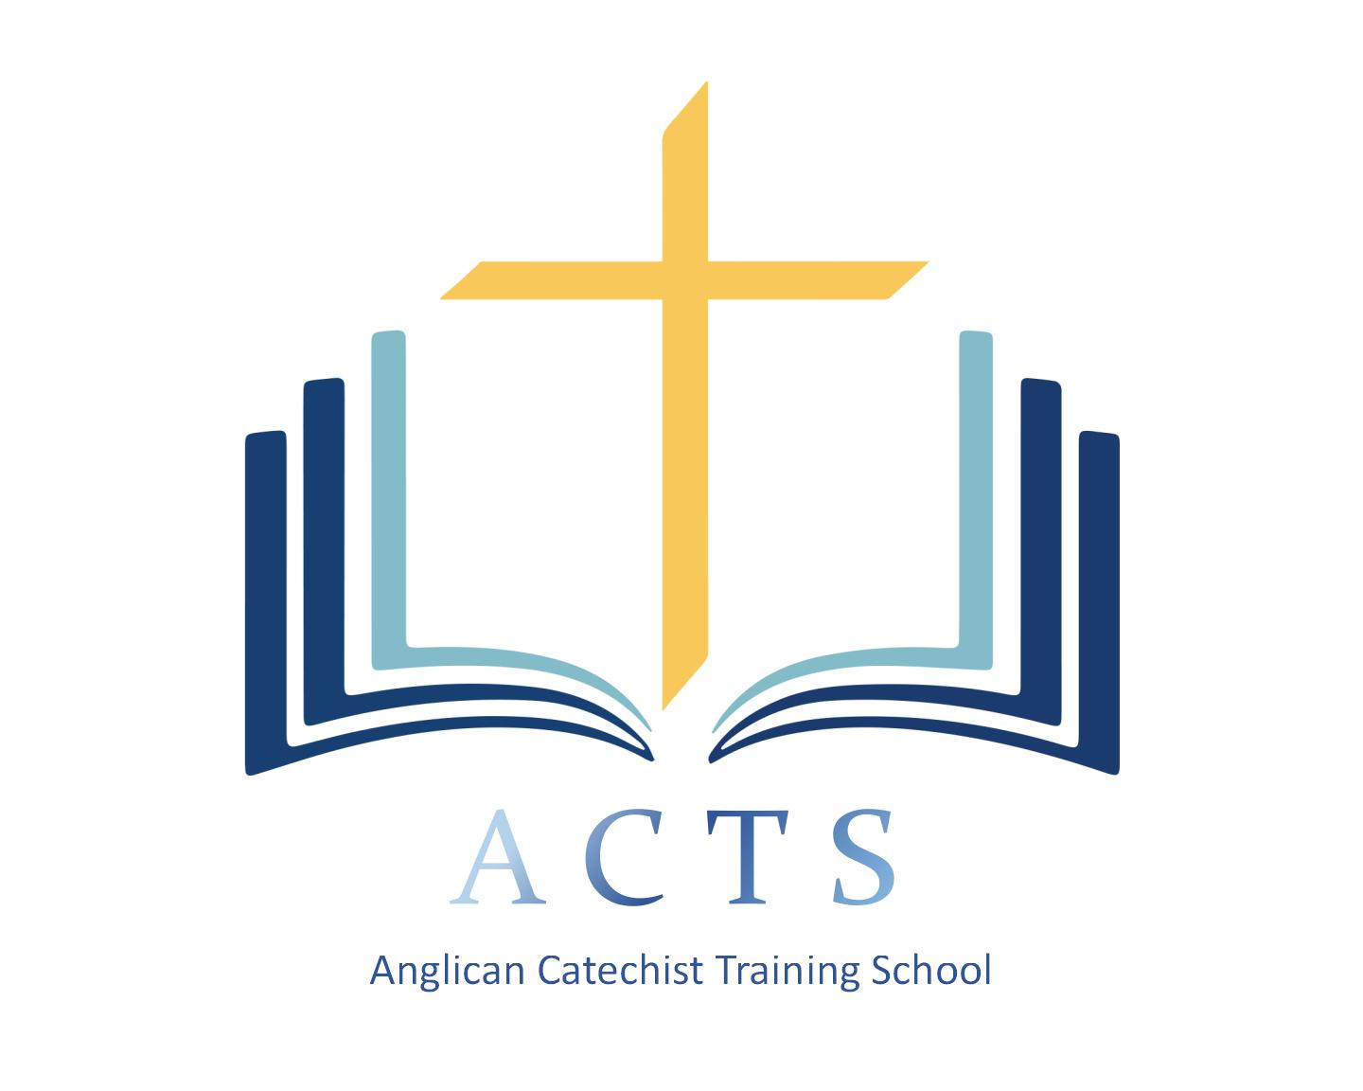
ACTS
Anglican Catechist Training School
Diocese of San Joaquin
APPLICATION FOR ADMISSION FOR YEAR 1
DUE July 30, 2021
EARLY REGISTRATION SPECIAL = $175: Return completed application by July 16, 2021
Regular Registration Rate = $200

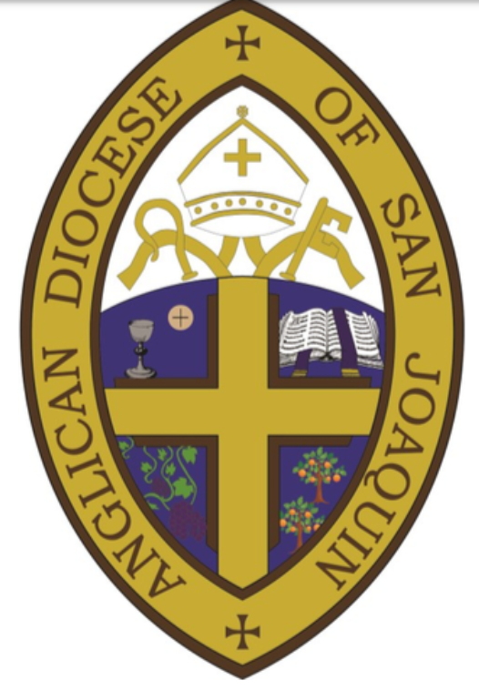
(Choose all that apply) I want to: teach catechism; be better prepared to do ministry; disciple others; grow spiritually
Application Requirement for Seeking Licensing:
- Completed Application which includes the following . . .
- Discernment with Clergy, who is over your congregation.
- Completed Clergy Recommendation Form—Due the same date this application is due.
- Completed background check—by application submission date. Call Diocesan office for where to obtain a background check.
FULL NAME: ________________________________________________________________________________________________
Address: __________________________________________________ __________________________ ________ _____________
Street Address (P.O. Box) City State Zip Code
Phone: Home ____________________________ Work ___________________________ Cell __________________________
Email____________________________________________________ Date of Birth______________________ Gender_______
Name of Congregation: _____________________________________ Communicant in this parish since___________
Have you met and discerned with your clergy your call to catechetical or other ministry? If so, when was this meeting? ______________________________________________________________________________________
BAPTISM
Church: _______________________________________ City/State: _______________________________ Date:____________
By______________________________________________________________________________

CONFIRMATION
Church: _______________________________________ City/State: _______________________________ Date:____________
By______________________________________________________________________________
FAMILY
Marital Status (S) _______ (D) _______ (W)_______ (M) _______
Spouse’s Name: _________________________________________________ Date of Marriage: _______________________
Children’s Names and Ages: ________________________________________________________________________________
________________________________________________________________________________________________________________
PERSONAL
Hobbies and Interests: ______________________________________________________________________________________
Organizations, societies, fraternal orders, etc. in which you participate or have participated:
__________________________________________________________________________________________________________________________________________________________________________________________________________________________________
Occupation: _________________________________________________________ How long: _____________________________
Brief Work History:__________________________________________________________________________________________ __________________________________________________________________________________________________________________________________________________________________________________________________________________________________
EDUCATION
Academic institutions attended with diplomas, degrees or certificates:
NAME OF INSTITUTION DIPLOMAS, DEGREES or CERTIFICATES
__________________________________________________________________ ______________________________________________
__________________________________________________________________ ______________________________________________
__________________________________________________________________ ______________________________________________
__________________________________________________________________ ______________________________________________
Answer the following questions in a separate document and attach to this application. (Typed answers are preferable.)
- Give a brief account of your testimony and history of your spiritual development (approximately 1000 words).
- How do you view the authority of Scripture?
- Describe your major strengths and how they have helped you in your life and in your vocation?
- Describe your weaknesses and how they have hindered you interpersonally and in your vocation.
- Describe what you believe to be your spiritual gifts.
- Describe your vision for ministry. Why would you like to be a catechist if that is one of your goals?
In order to complete this application, the applicant needs to complete a background check. Contact Diocesan Administrator at 559-244-4828 or go to https://oag.ca.gov/fingerprints/locations.
Signature of Applicant: ________________________________________________________ Date: _______________________
Please return completed application (including background check and clergy recommendation) and $200 to the Anglican Diocese of San Joaquin office no later than July 30, 2021!
EARLY REGISTRATION SPECIAL = $175: Return completed application by July 16, 2021
Beth Conkle, ACTS, 5455 N. Marty Ave. #119, Fresno, CA 93711; 559-455-7346
As part of the application process for the Anglican Catechist Training School, the applicant and his/her clergy (who is over the Congregation) meet to discern applicant’s calling to the ministry of a Catechist or other lay ministry. Clergy must then complete this form and return this to Beth Conkle no later than July 30, 2021.

Clergy Recommendation

- How long have your known the applicant and in what capacity?____________________________ _____________________________________________________________________________________________________
- How long has the applicant been attending your church?____________________________________
- What do you discern this person’s spiritual gifts are? ____________________________________________
____________________________________________________________________________________________________________________________________________________________________________________________________________________
- In what capacities does this person minister within your congregation at present? ______________________________________________________________________________________________________________________________________________________________________________________________________________________________________________________________________________________________________________________________
- What strengths does this person possess?_________________________________________________________ ______________________________________________________________________________________________________________________________________________________________________________________________________________________________________________________________________________________________________________________________
- What are some areas in which this person needs to grow and mature? _________________________ ______________________________________________________________________________________________________________________________________________________________________________________________________________________________________________________________________________________________________________________________
- Is this person one who you would entrust to a teaching ministry such as youth or adult catechism? If not, what would this person need in order to be equipped and prepared for such a ministry?
____________________________________________________________________________________________________________________________________________________________________________________________________________________________________________________________________________________________________________________________________________________________________________________________________________________________________________________________________________________________________________________________________________________________________________________________________________________________________________________________
- Are you willing to mentor or have another clergy or lay leader in your church mentor this person in order to prepare s/he for a catechetical or other ministry? Yes_______ No ________
If not, why not?_______________________________________________________________________________________ ______________________________________________________________________________________________________________________________________________________________________________________________________________________________________________________________________________________________________________________________
Name and contact of clergy or lay leader who will be assigned to mentor the applicant:
NAME: ________________________________________________________________________________________________
Address: __________________________________________________ __________________________ ________ _____________
Street Address (P.O. Box) City State Zip Code
Phone: Work _________________________________________ Cell ________________________________________
Email___________________________________________________________________________________________________
Name of Congregation: __________________________________________ Role:______________________________
Rural Dean, Rector, Deacon, lay leader

The applicant has met with me on ____________________________________________, and, thus, I recommend this person for participation in ACTS. Yes_________ No__________

________________________________________________________________________ ______________________________ Signature of Clergy Date

Return this form to Beth Conkle at 5455 N. Marty Ave. #119, Fresno, CA 93711 no later than July 30, 2021! You may also email a PDF of this form to eaconkle.acts@gmail.com.

